Database System Engineering and Distributed Backend Development
Course Code: 25CS1302E
TRIGGERS AND STORED PROCEDURES
Roll No:2520030189
Name:Alluru Akshaya
Section:7

Query-1:
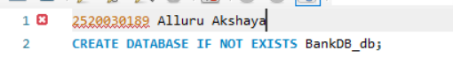
Output:

Query-2:

Output:

Query-3:
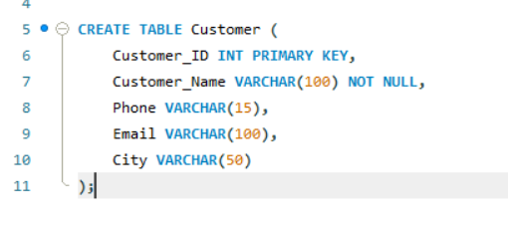

Output:
Query-4:
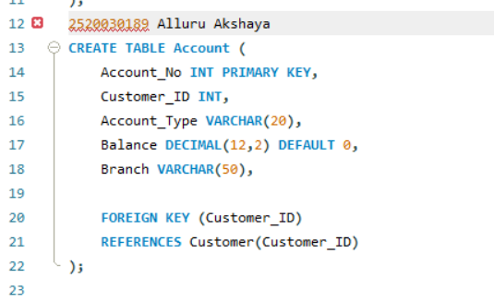
Output:
Query-5:
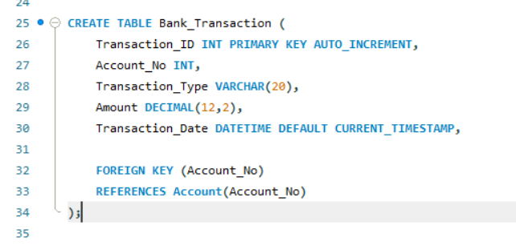
Output:

Query-6:
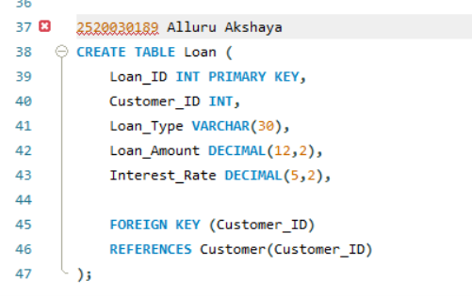
Output:
Query-7:
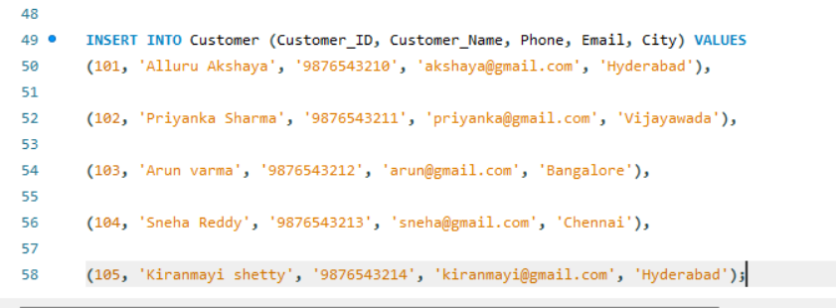
Output:

Query-8:
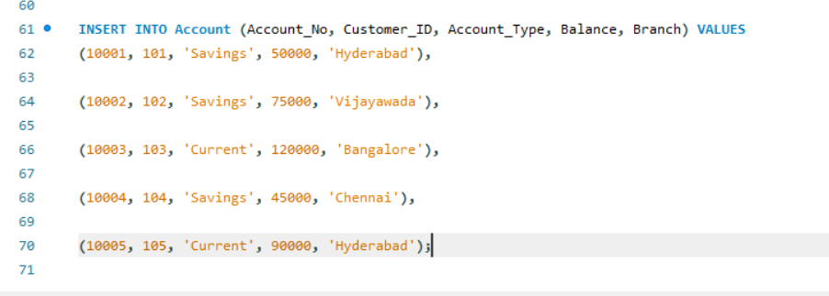

Output:
Query-9:
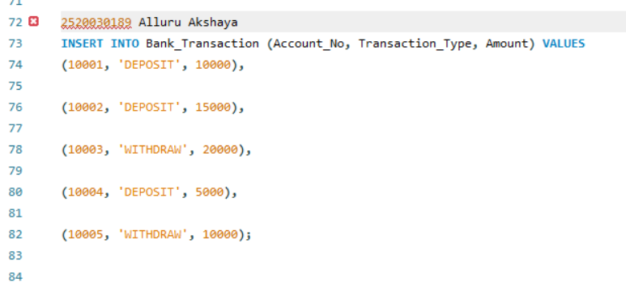
Output:

Query-10:
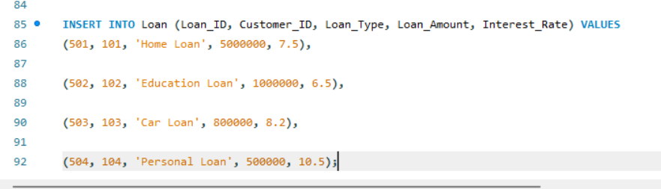
Output:

Query-11:


Output:
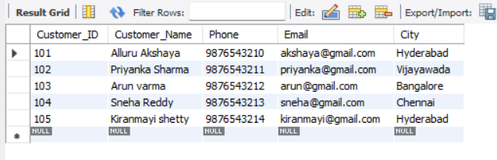
Query-12:
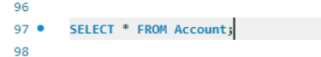
Output:
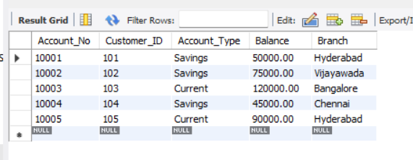
Query-13:
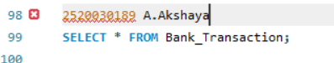
Output:
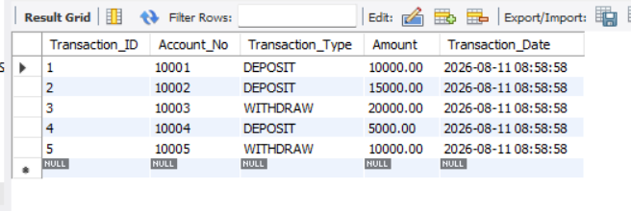

Query-14:
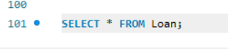
Output:
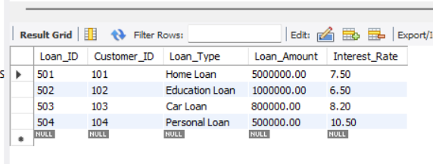
Query-15:
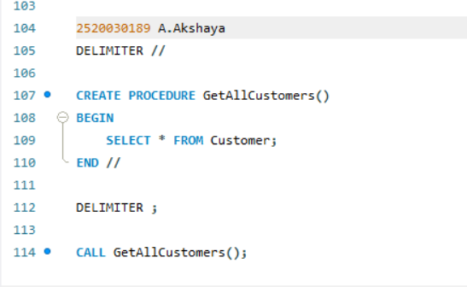
Output:
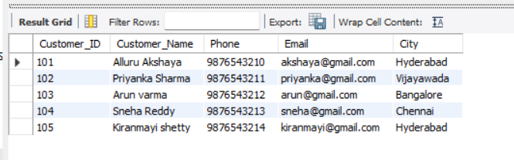

Query-16:
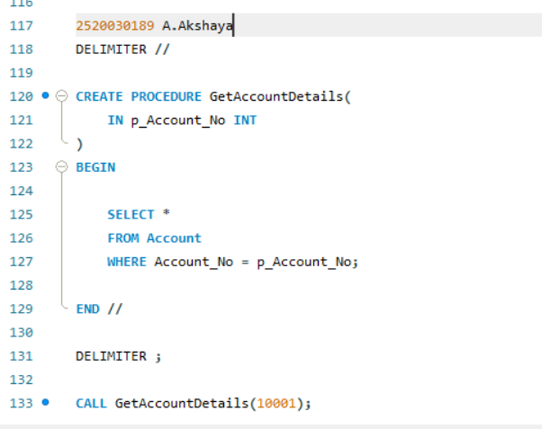
Output:
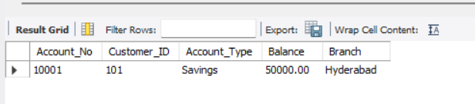
Query-17:
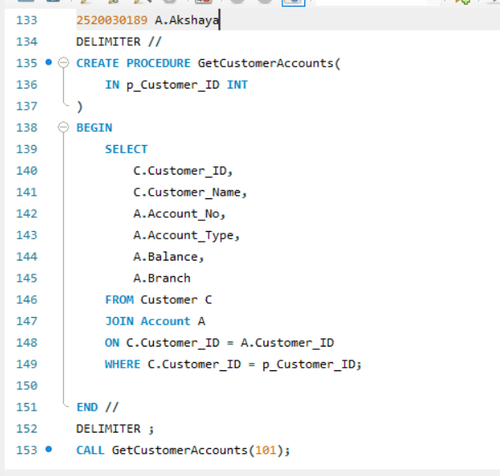

Output:
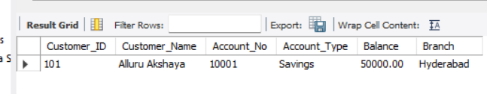
Query-18:
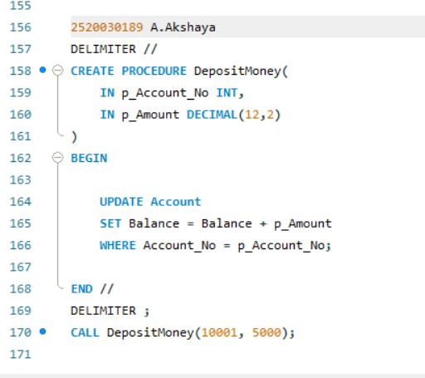
Output:
Query-19:
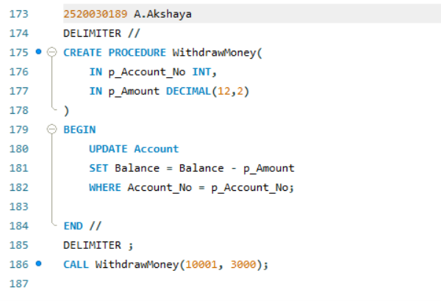

Output:

Query-20:
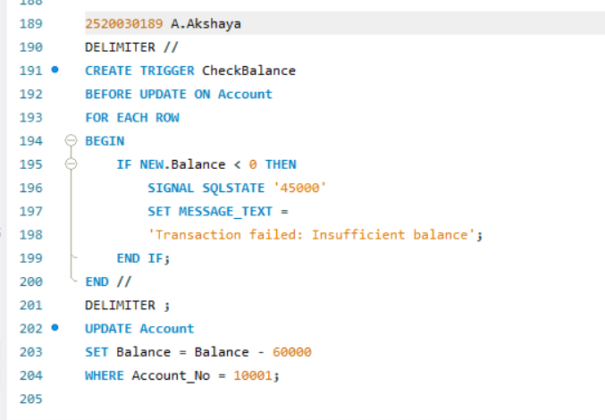
Output:
Query-21:
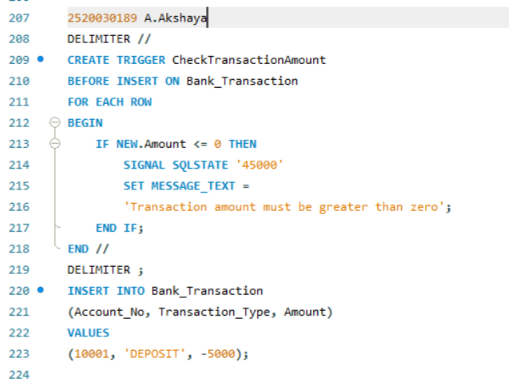
Output:
Query-22:
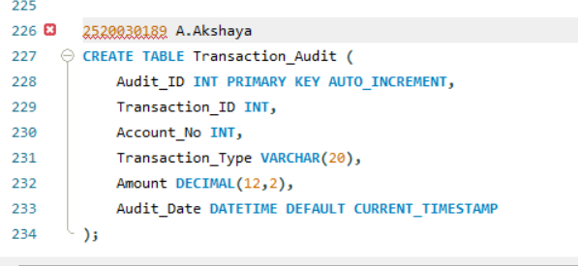
Output:
Query-23:
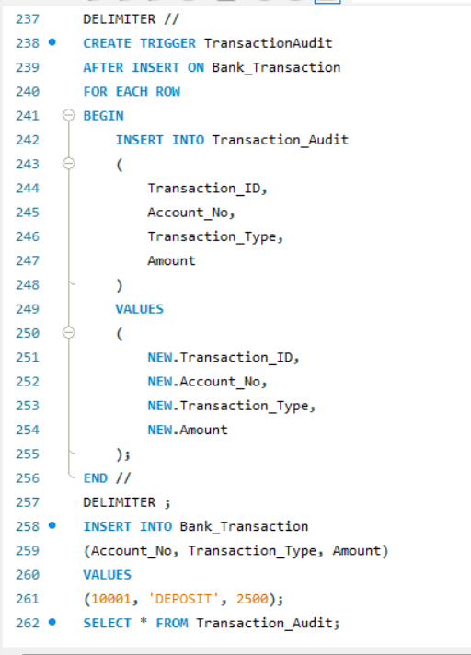
Output:
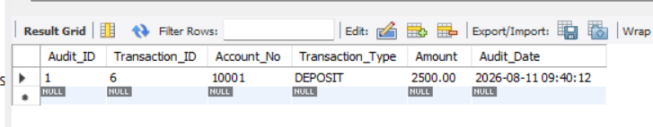
Query-24:
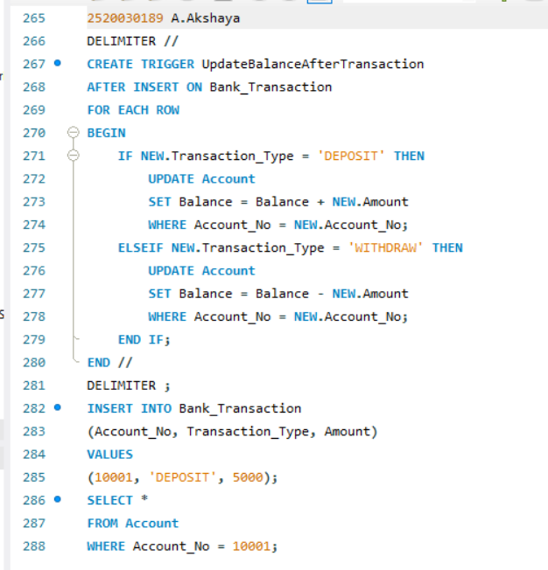
Output:
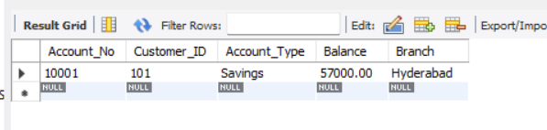
Query-25:
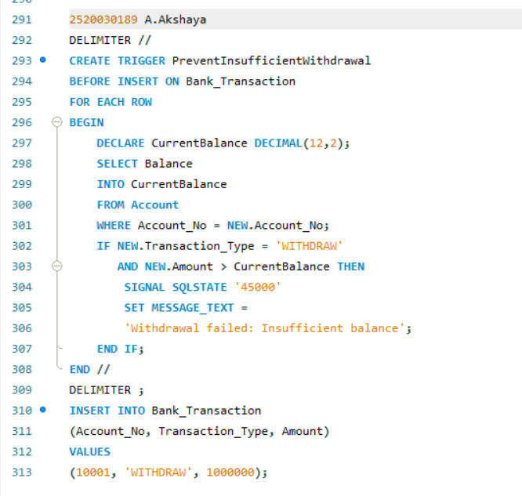
Output:

Query-26:
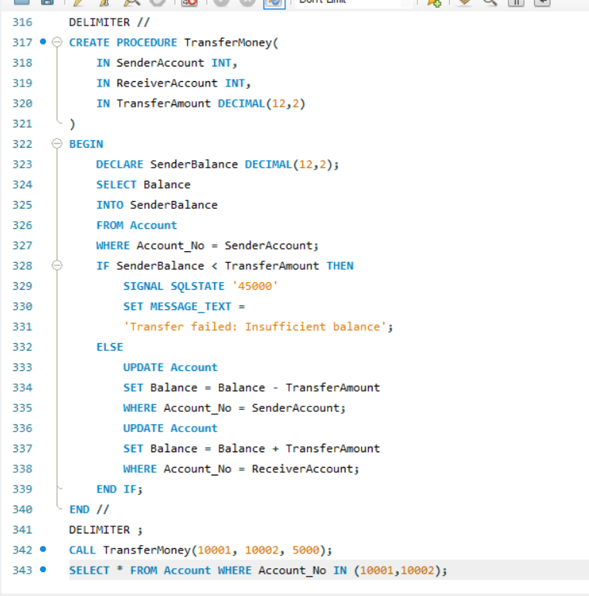
Output:
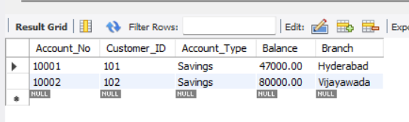

Query-27:
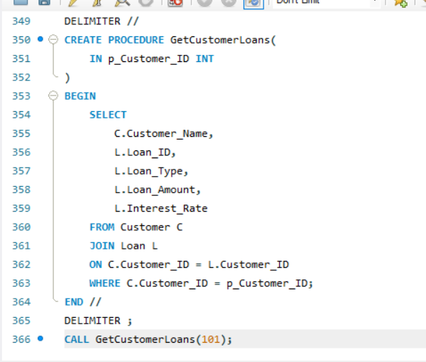
Output:
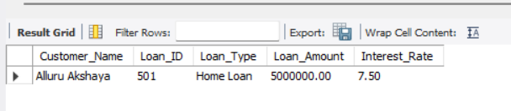
Query-28:
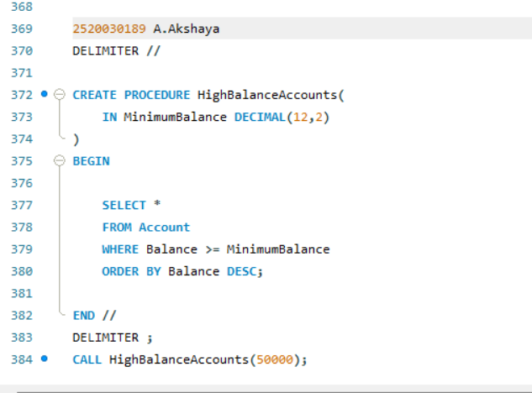
Output:
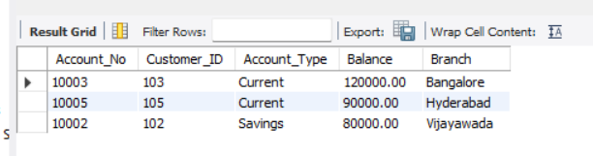
Query-29:
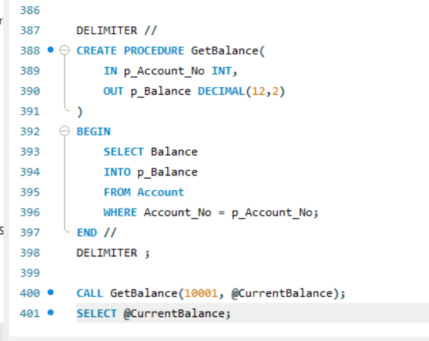
Output:
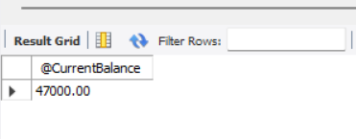

Query-30:

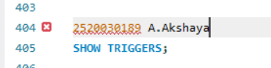
Output:
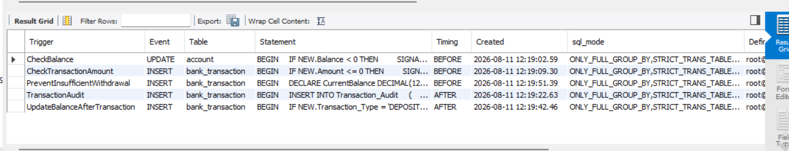
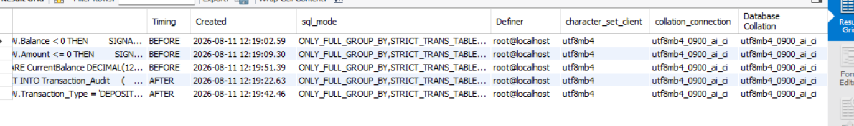
Query-31:
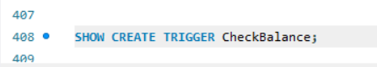
Output:
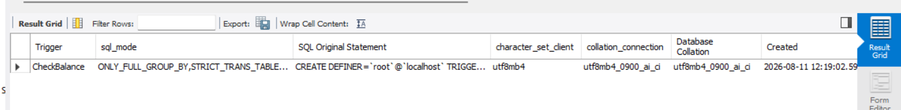
Query-32:
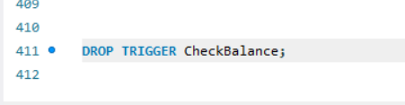
Output:

Query-33:
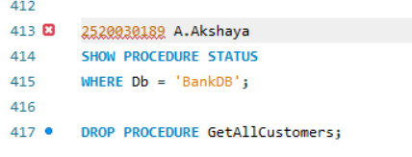
Output:
